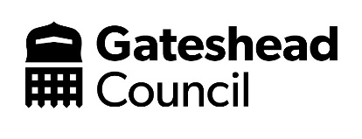
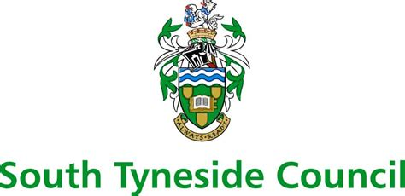
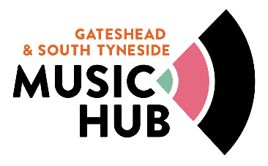
Gateshead and South Tyneside Music Education Hub
Charging, Remissions and Subsidy Policy
Updated 19th May 2022

Background and Introduction
Gateshead Council is the accountable body for Gateshead and South Tyneside Music Hub (GSTMH) and holds the contractual relationship with Arts Council England.
Gateshead Council holds a partnership agreement with South Tyneside Council for the delivery of hub funded music services in that local authority area.
Both Music Services are accountable to the policies of their relevant local authority, and as such have different charging models.

Gateshead Music Service:
Schools buy into SLAs for a range of services. Charges are subsidised through the Music Education Hub fund with further subsidies in place for schools with high levels of Free School Meal pupils. All schools can now apply for a further subsidy of between £300 and £500 (dependent on their SLA) on completion of an annual data survey (deadline 18th July).
All Whole Class Instrument Tuition is provided FREE to pupils in schools, through their school SLA.
GMS charges schools direct for small group and individual tuition. Schools offer a range of charges and remissions to parents, dependent on the demographic of their children, and their own school setting. All schools also subsidise individual and small group tuition, at a range of levels, in line with their own school charging and remissions policy. Parents are advised to contact their school setting for more information.
Individual tuition through the music service is charged at a subsidised rate for all parents (currently £16 per half hour). We offer further subsidies for home education children, LAC, FSM etc. Parents can contact the music service for more information.
All pupils taking part in GMS tuition are provided with an instrument Free of Charge, on signing an Instrument Loan Agreement.
We offer the Instrumental Purchase Scheme with no charge for administrating purchases.
All children are invited to join our ensembles for which there is currently no Fee – fully subsidised through the Music Education Hub funding.
We offer high quality workshops in schools which are very popular – these are also subsidised through the Music Education Hub fund, keeping charges down so more pupils can enjoy performances.
Where possible, we do not charge pupils and schools for large scale performances and events. These are either funded through the Music Education Hub Fund or ticket sales. Prices for tickets are considered for every event to keep costs down (£3 for adults and children free for ensemble concerts). We do charge parents to attend events such as Spring Sing at Sage, to help finance the event, keeping costs as low as possible. Partnership and fundraising supports keeping charges low – for example, The Nicola Benedetti Residential week which is Free to all participants, and Conductive Music workshops in schools.
GMS will soon be able to offer additional bursaries through the Gateshead Music Trust, due to be launched Autumn 2022.
Contact Barbaramurray@gateshead.gov.uk if you would like more information regarding our charges, remissions, and subsidies.

South Tyneside Music Service:
South Tyneside Music Service operates Pay As you Go service with tuition requests submitted by schools on a termly basis.
Infant, Junior, Primary and Special schools are offered one FREE term of Whole Class tuition each funding period.
STMS charges schools direct for small group and individual tuition. Schools may offer a range of charges and remissions to parents, dependent on the demographic of their children, and their own school setting. Schools may also subsidise tuition in line with their own charging and remissions policy. Parents should contact their school setting for more information.
Individual small group tuition through STMS is charged at £32/£35 per hour pro- rata.
Whole class tuition beyond the FREE term is charged at £41/£45 per hour pro- rata.
All pupils taking part in STMS tuition have access to instruments Free of Charge, a signed Instrument Loan Agreement is required for those instruments used in individual/small group tuition
We offer an Instrumental Purchase Scheme with no charge for administrating purchases.
Children are invited to join our various ensembles for which there is currently no Fee – these are fully subsidised through the Music Education Hub funding.
We offer access to high quality workshops/music opportunities – these are often subsidised through the Music Education Hub fund, keeping charges down so more pupils can enjoy performances.
Where possible, we do not charge pupils and schools for participation in large scale performances and events. These are either funded through the Music Education Hub Fund or via programme sales. Any ticket price levied for parents/performance guests is carefully considered to keep costs down (usually £3 for adults and £2 for children/concessions) or often a donation dependent of the event.
Contact lynn.freer@southtyneside.gov.uk if you would like further information.

